KARAN PATEL
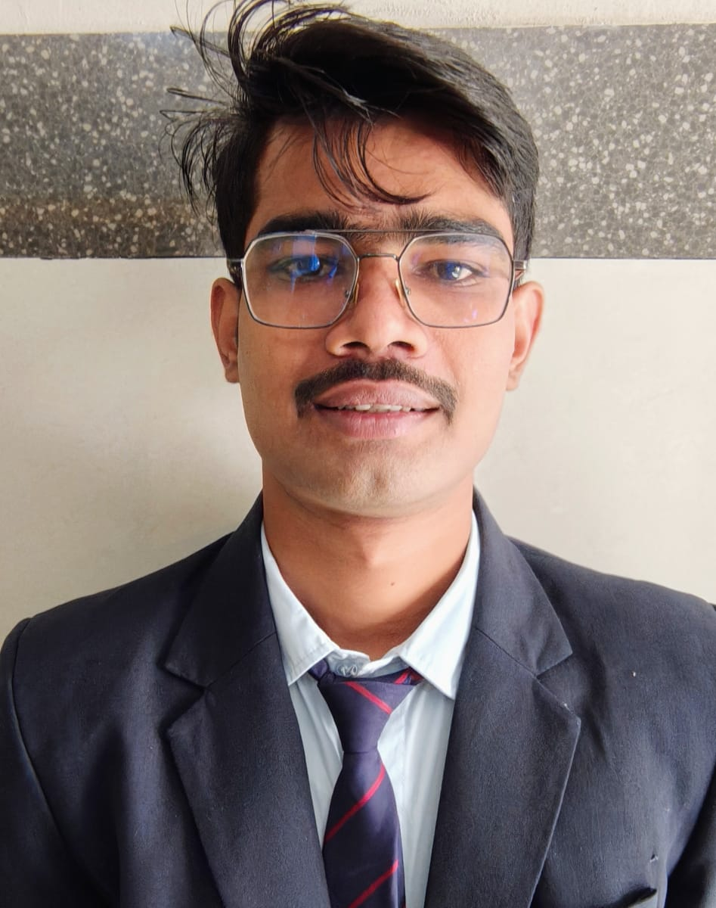

ShivShakti nagar,Indore (M.P.) 452011
8251038187 karanp825103@gmail.com
https://www.linkedin.com/in/karan-patel-294553311

Career Objective: To begin my career as a Java Full Stack Developer, where I can enhance my technical skills, gain practical experience, and contribute to developing efficient and user-friendly web applications.

Academic Record:
Professional Qualification:
- Pursuing B.Tech from Acropolis Institute of Technology and Research, Indore affiliated to RGPV Bhopal with specialization in CSIT. (2023-27) (CGPA- 6.8).

Educational Qualifications:
- SSC (10th) from J.N.V. Nowgong(CBSCE) with 72% in 2021.
- HSC (12th) from Shri Balaji Adarsh H.S. School, Chhatarpur (M.P. Board) with 71% in 2023.

Technical Skills : C++, OOPS ,Java, MySQL, React Js , DSA with java.

Minor Project:
- Title: SAFECROSS: Automatic Railway Crossing Gate System
- Description: An Iot system automatically controls railway crossing gates using real-time train detection through multiple sensors, preventing accidents and ensuring safe transportation.
- Git Repo Link:- https://github.com/kris743/SAFECROSS-Automatic-Railway-Crossing-Gate-System
- Role: Hardware System Manager & Project Spokesperson Duration: November 2025 - January 2026.

Co-curricular Activities:

Participant PRARUPAM (Aarohan) 2025 -A Prototype Competition GSITS Indore.

Participant Tinkercase 3.0 2025 – A National Level Hardware Showcase Competition DTU Delhi.

Participat Void Breaker(Tech-O-Utsav) 2025 AITR Indore.

Participant Fluxus –Web development workshop(2024) IIT Indore.

Participat Innovate Expo(Tech-O-Utsav)- media compressor app(2024) AITR Indore.

Rewards & Accolades:

Certifications:
- Certified in NPTEL Data Science.
- Certified in NPTEL Fundament of Object Oriented Programming.
- Certified in NPTEL Data Base Management System.
- Certified by Google Cloud Skill Boost: Cyber Security.

Strengths : Analytical Sense.
Areas of Improvement : Interaction skills.
Hobbies : Reading.
Areas of Interest : Badminton, Coding Problem Solving.

Personal Details:
Date of Birth : 04/04/2005
Gender : Male
Nationality : Indian
Marital Status : Unmarried Languages Known : Hindi, English, Mother Tongue : Hindi

Father’s Name : Mr. Rajendra Prasad Patel
Permanent Address : Vill.-Para,Post-Bikrampur,Tah.-Rajnagar,Dist.-Chhatarpur,(MP).

Declaration: I hereby declare that the information furnished above is true to the best of my knowledge.

Date: 7/11/2025
Place: Indore Karan Patel

